

Store with IPFS – Decentralized File Upload  
  
**Objective/Aim:**  
  
 To understand how to upload and store files on IPFS (InterPlanetary File System) and retrieve them using a unique content identifier (CID).



**Apparatus/Software Used:**

* Laptop/PC
* Browser
* IPFS node (Pinata service)
* MetaMask (optional, for blockchain integration)
* Internet connection

**Theory/Concept:**

* IPFS: A decentralized file storage protocol that uses content addressing (hashes) instead of location addressing.
* Each file uploaded to IPFS is given a CID (Content Identifier).
* Files remain accessible as long as they are pinned or hosted on IPFS nodes.
* Used in blockchain projects for NFT metadata, documents, images, videos.



**Procedure:**

**Step 1:** Visit <https://pinata.cloud/> and create a free account.

**Step 2:** Log in and go to the Upload section on the Pinata dashboard.

**Step 3:** Upload any file (e.g., .txt, .png, .pdf) from your system.

**Step 4:** After upload, Pinata will generate a CID(Content Identifier) for your file.

**Step 5:** Copy the CID and open it in a browser using a public gateway, e.g., https://ipfs.io/ipfs/<CID>.

**Step 6:** Test retrieving the file from different browsers or devices to confirm decentralized access.

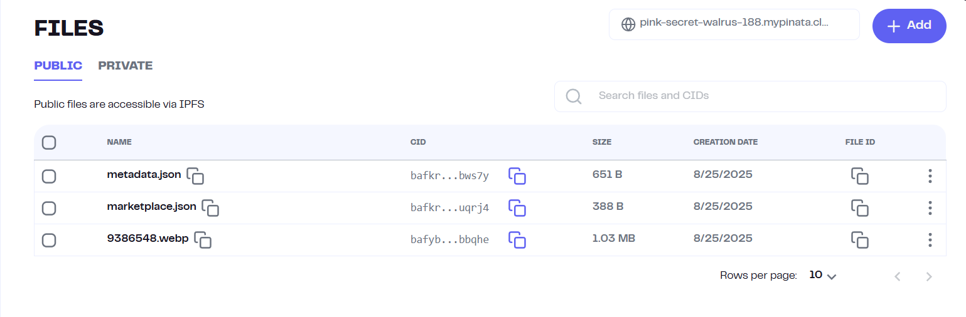

**Observation Table:**

|  |  |  |  |
| --- | --- | --- | --- |
|  |  |  |  |
|  |  |  |  |
|  |  |  |  |
|  |  |  |  |
|  |  |  |  |
|  |  |  |  |
|  |  |  |  |



* File uploaded successfully to IPFS.
* CID generated (unique hash for the file).
* File accessible via IPFS public gateway link.
* Changing the file content produced a completely new CID.
* Stored CID can be used in blockchain apps for file reference.